Q1 | Given a list of delivery timestamps as strings (e.g., ['2024-06-01 14:30', '2024-06-02 09:15', '2024-06-03 20:45']), use pandas and pd.to_datetime() to convert them into datetime objects and print the result.
Code | import pandas as pd  df = pd.read_csv("flipkart_orders.csv")  df["order_date"] = pd.to_datetime(df["order_date"])  df["year"] = df["order_date"].dt.year  df["month"] = df["order_date"].dt.month  df["weekday"] = df["order_date"].dt.day_name()  print(df)
Output | 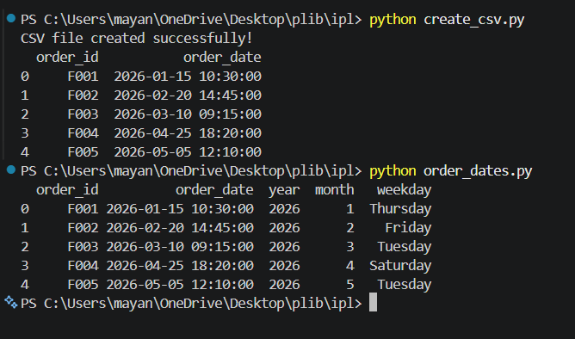

Q2 | Load a CSV file containing order dates from a Flipkart-style order history (column: 'order_date', format: 'YYYY-MM-DD HH:MM:SS'). Extract the year, month, and weekday for each order and add them as new columns in the DataFrame.
Code | import pandas as pd  df = pd.read_csv("flipkart_orders.csv")  df["order_date"] = pd.to_datetime(df["order_date"])  df["year"] = df["order_date"].dt.year  df["month"] = df["order_date"].dt.month  df["weekday"] = df["order_date"].dt.day_name()  print(df)
Output | 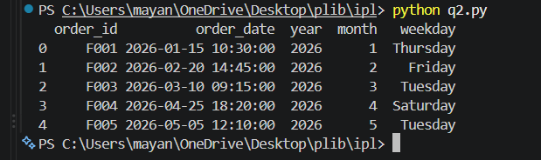

Q3 | Set the 'order_date' column as the index of your DataFrame and use resampling to calculate the total number of orders placed each week.<br><br><em><strong>Hint:</strong> Use df.resample('W').size() after setting the datetime index.</em>
Code | import pandas as pd  data = {  "order_date": [  "2026-01-01",  "2026-01-02",  "2026-01-03",  "2026-01-05",  "2026-01-07",  "2026-01-10",  "2026-01-12",  "2026-01-15",  "2026-01-18",  "2026-01-20"  ],  "order_id": [  101, 102, 103, 104, 105,  106, 107, 108, 109, 110  ]  }  df = pd.DataFrame(data)  df.to_csv("orders.csv", index=False)  print("CSV file successfully created!")  print("\nOriginal Data:")  print(df)  df = pd.read_csv("orders.csv")  df["order_date"] = pd.to_datetime(df["order_date"])  df = df.set_index("order_date")  weekly_orders = df.resample("W").size()  print("\nWeekly Total Orders:")  print(weekly_orders)
Output | 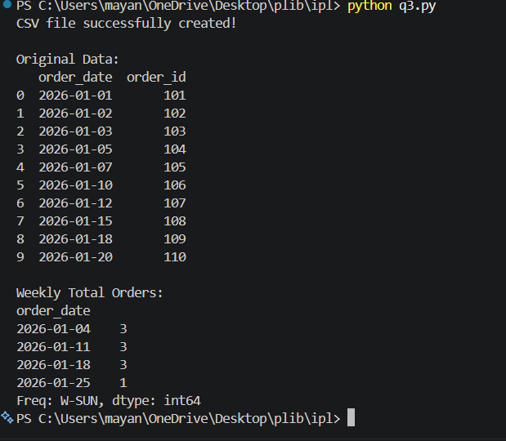

Q4 | Suppose you have a DataFrame of Instagram posts with a 'posted_at' column in UTC. Convert these timestamps to 'Asia/Kolkata' timezone and display the first 5 converted times.
Code | import pandas as pd  data = {  "post_id": [1, 2, 3, 4, 5, 6],  "posted_at": [  "2026-08-20 10:00:00",  "2026-08-20 12:30:00",  "2026-08-21 08:15:00",  "2026-08-21 14:45:00",  "2026-08-22 09:00:00",  "2026-08-22 18:30:00"  ]  }  df = pd.DataFrame(data)  df["posted_at"] = pd.to_datetime(df["posted_at"], utc=True)  df["posted_at_kolkata"] = df["posted_at"].dt.tz_convert("Asia/Kolkata")  print("First 5 converted times:")  print(df["posted_at_kolkata"].head(5))
Output | 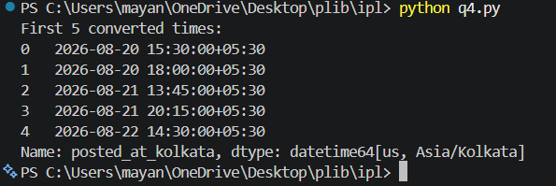

Q5 | Create a new feature called 'is_weekend' in your DataFrame that marks True if an order was placed on Saturday or Sunday, and False otherwise.<br><br><em><strong>Constraint:</strong> Do not use any external libraries except pandas and numpy.</em>
Code | import pandas as pd  import numpy as np  data = {  "order_id": [101, 102, 103, 104, 105, 106],  "order_date": [  "2026-08-17", # Monday  "2026-08-18", # Tuesday  "2026-08-21", # Friday  "2026-08-22", # Saturday  "2026-08-23", # Sunday  "2026-08-24" # Monday  ]  }  df = pd.DataFrame(data)  df["order_date"] = pd.to_datetime(df["order_date"])  df["is_weekend"] = np.where(  df["order_date"].dt.dayofweek >= 5,  True,  False  )  print("Orders with is_weekend feature:")  print(df)
Output | 